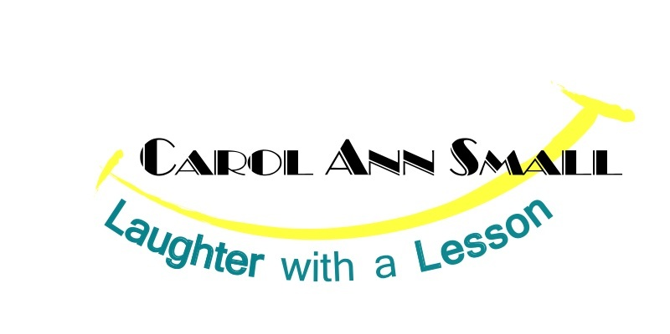
Carol Ann Small, founder and CEO of Laughter with a Lesson, is a nationally recognized Motivational Humorist and Stress and Work/Life Balance expert.

Carol Ann offers a unique perspective on the benefits of finding humor in the workplace and everyday life. Increase productivity, reduce stress, and improve communication with a more positive work force.
Her customized, humorous presentations have entertained and educated corporations, associations, educators and the general public for more almost two decades. Before Carol Ann became a professional speaker, she was a court stenographer. (But sitting in the corner and being quiet wasn’t for her!) She has also worked for Fortune 500 companies and in Higher Education. She has appeared at the Majestic Theatre, the Comedy Connection, and Panache in NYC. Carol Ann is a Stress and Life Balance Expert, Motivational Humorist and Author who imparts wisdom with a twist of real-life humor.
Carol Ann has appeared on Good Morning America and WGME News. She shows her purpose of finding joy in your life in her book “HUMOR US” - the Power of Laughter.
From resolving conflict to building self-esteem, Carol Ann will inform and entertain audiences. Carol Ann’s programs: If I Only Go Around Once in Life, Why am I so Dizzy? – Finding Work/Life Balance; De-Stress and Get Motivated; Adventures in Attitudes; B.Y.O.B – Banish Your Own Burnout, Retrain Your Brain: Neuroscience; and Are you Talkin’ to me? – Behavioral Styles teach participants how to perform at their optimum level.

While most speakers come to the podium without the benefit of any formal speech training, Carol Ann is a 20 year Professional Member of the National Speakers Association and graduated cum laude with her BSSP in Speech Communications and Performing Arts from Emerson College in Boston.
Carol Ann is a Wiley Workplace Learning Solutions Trainer and wellness consultant, former Officer of National Speakers Association NE Board and a CLL, Certified Laughter Leader
And, Carol Ann was even elected PT of NASA…. She runs the space program. Ok, well, actually, NASA, the National Association for Scattered Adults – adults trying to find work/life balance.
That’s why her programs on stress, work/life balance, communicating effectively and science of the brain are so enlightening to her busy, overscheduled audience members.

